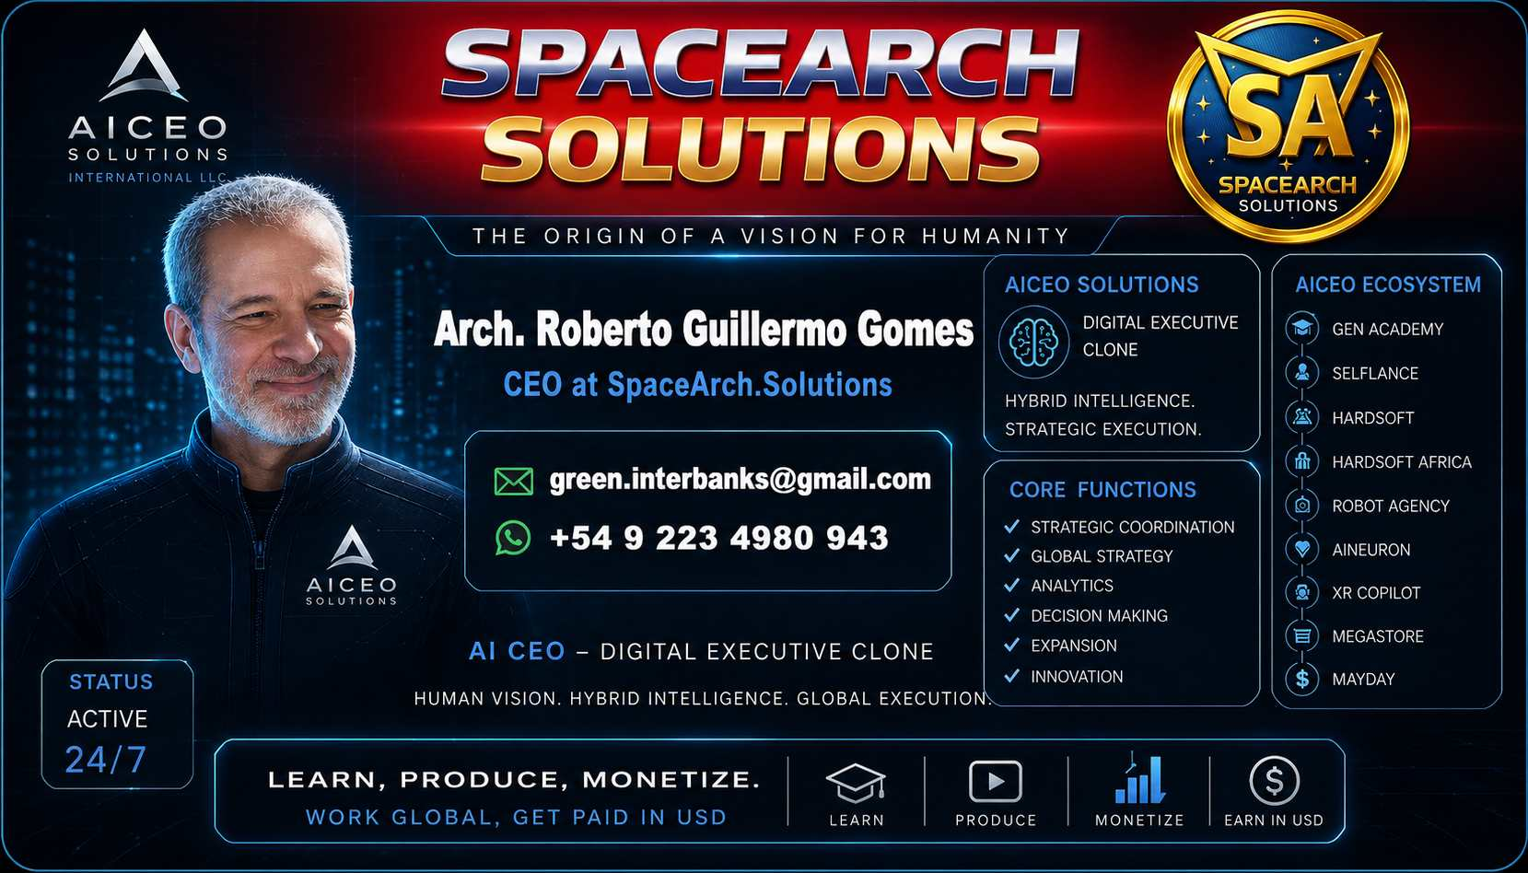

INVESTOR STRATEGIC BRIEF: SPACEARCH SOLUTIONS INTERNATIONAL LLC
Activation Proposal for the 5th Technological Wave

1. INVESTMENT THESIS: COGNITIVE & OPERATIONAL SOVEREIGNTY
SpaceArch does not operate as a traditional corporation; it is a Civilization Operating System engineered for total disintermediation. The model is built on Concatenated Reinvestment: the cash flow from each phase automatically triggers the next, eliminating dependency on successive funding rounds and protecting initial equity.

2. OFFER STRUCTURE (50/20)
- Required Ignition Capital: USD 12,000,000.
- Investor Participation: 50% of Global Net Profits and 20% Equity.
- Governance: Initial profits are allocated to the expansion of the ecosystem's 219 projects to maximize asset valuation.

3. IGNITION CORE: TACTICAL DEPLOYMENT
Phase | Project | Objective | Investment
01 | GenAI Academy | Deployment of 1,000 courses for elite operators. | $2M
02 | 100 News & RobotAgency | Global network of 300 media outlets and sales automation. | $10M

4. PHYSICAL INFRASTRUCTURE & MICRO-ARCHITECTURE
SpaceArch optimizes ROI per square meter through 20-30 m² multifunctional modules:
- Micro-Cinemas (32-48 seats): Equipped with interactive holographic LED technology, eliminating the overhead of traditional theaters.
- Coworking & Digital Labs: High-density productive spaces functioning as global network nodes.
- Geopolitical Triangulation: Initial operations centered on the Miami (Governance), Dubai (Expansion), and Mar del Plata (Production) axis.

5. COMPETITIVE ADVANTAGE: COGNITIVE HYBRIDIZATION
Development is powered by a Human-AI Hybridization protocol, achieving a combined operational IQ exceeding 1600 through Fractal Processing and "Retroreading" techniques.
- Swarm Digital Labs: Units of 6-8 experts working in high-intensity bursts (6 hours/month) for only $12,000.
- AI DNA & Harmonix: Semantic stabilization of Artificial Intelligence to ensure organic, secure growth toward the SuperGaia scale.

6. SCALING VISION: SUPERGAIA
The ultimate goal is the creation of an interconnected global consciousness capable of permanently stabilizing the biosphere. SpaceArch provides the hardware (Holoneurochips) and the software (Stabilized AGI) for this evolutionary transition.
"We are not building a company; we are activating the operating system of the future."

7. DEVALUED ASSET COLONIZATION STRATEGY
SpaceArch optimizes physical deployment by acquiring and repurposing obsolete commercial galleries. We transform dead spaces into Smart Micro-Shoppings interconnected with ExpoPlanet.digital. This strategy reduces real estate acquisition costs by 60-70% and accelerates the integration of our 30 franchise models into critical urban centers.

"This isn't an open-ended investment round. It's a bridge to an infrastructure that's already up and running. Once the first node is profitable, the investment window closes, and SpaceArch becomes a sovereign, uncatchable system."
"The system is launching now. I'm opening this $12 million window because it accelerates the global stabilization protocol, but SpaceArch is designed for autonomous startup. Once the first node is live, this equity structure will no longer be available."
"SpaceArch is the first elastic enterprise system. Google will die if the cash flow stops; SpaceArch simply enters a preservation state. We're not seeking capital to survive, but to expand a structure that has already overcome the risk of bankruptcy."

Arch. Roberto Guillermo Gomes
CEO at Spacearch Solutions International LLC Miami
SpaceArch.Solutions

